**VM VIRTUAL BOX DOWNLOAD STEPS**

**Step1 -> Downoad Virtual box:**

**<https://www.virtualbox.org/wiki/Download_Old_Builds_7_0>**

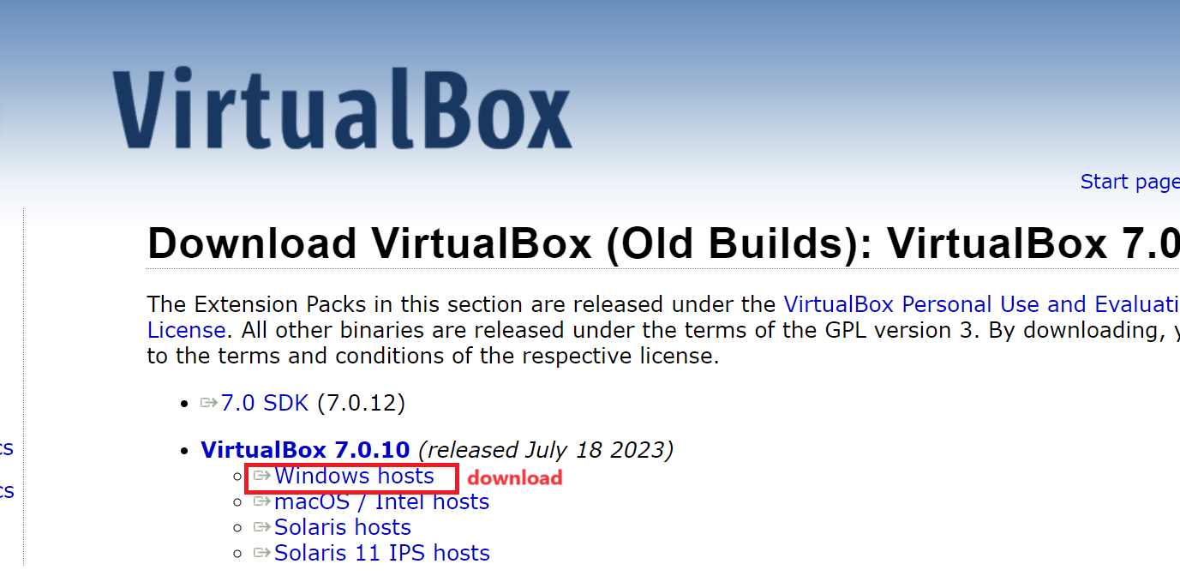

**Step 2 -> install virtualbox**

**Note: if you get error like**

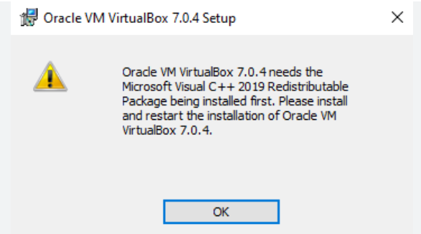

Visit:

<https://learn.microsoft.com/en-us/cpp/windows/latest-supported-vc-redist?view=msvc-170>

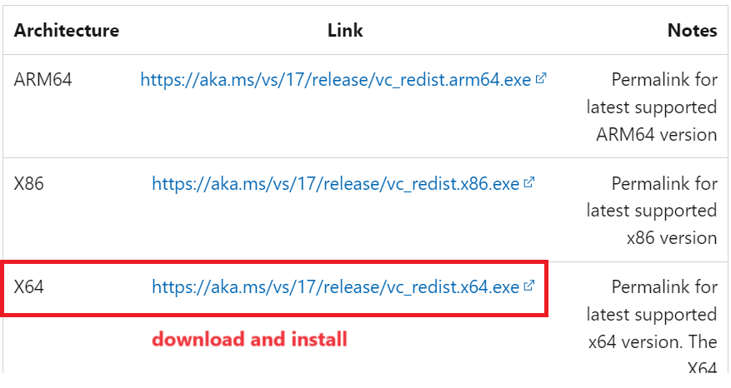

**Step 3-> Dowmload Centos 7 ISO image:**

**<https://www.centos.org/download/>**

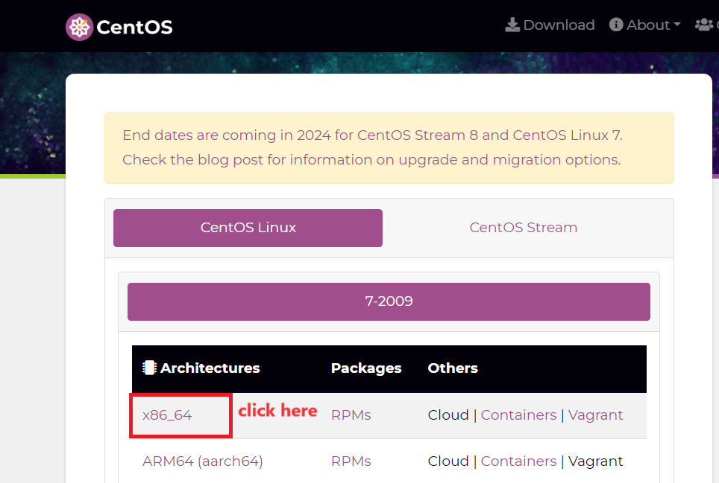

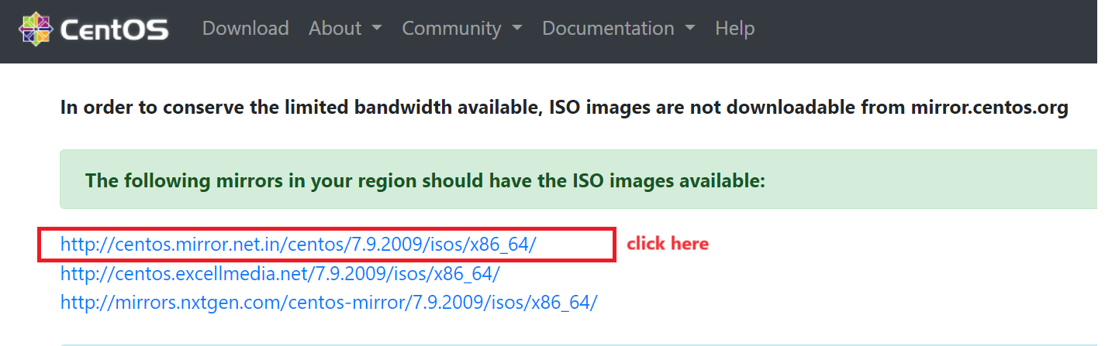

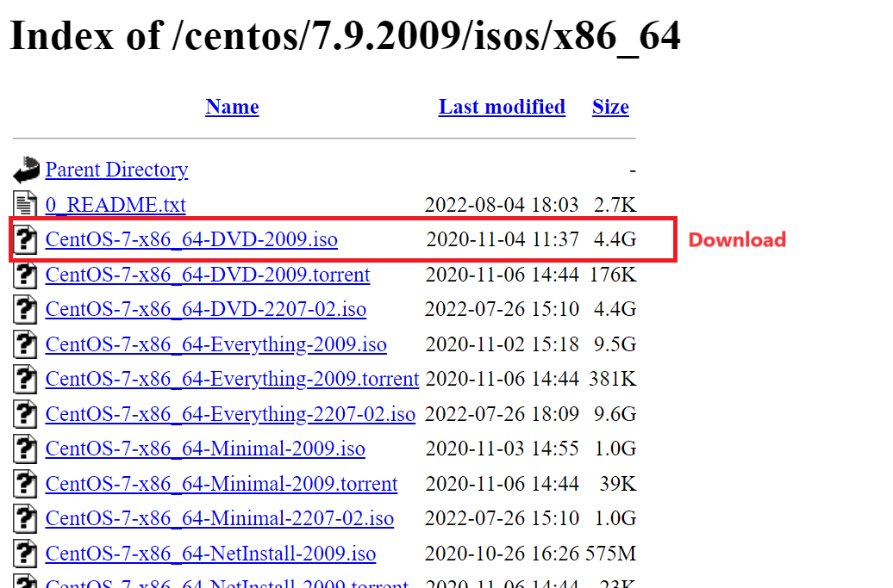

**Step 4 -> Create Virtual Machine Inside VIrtual Box**

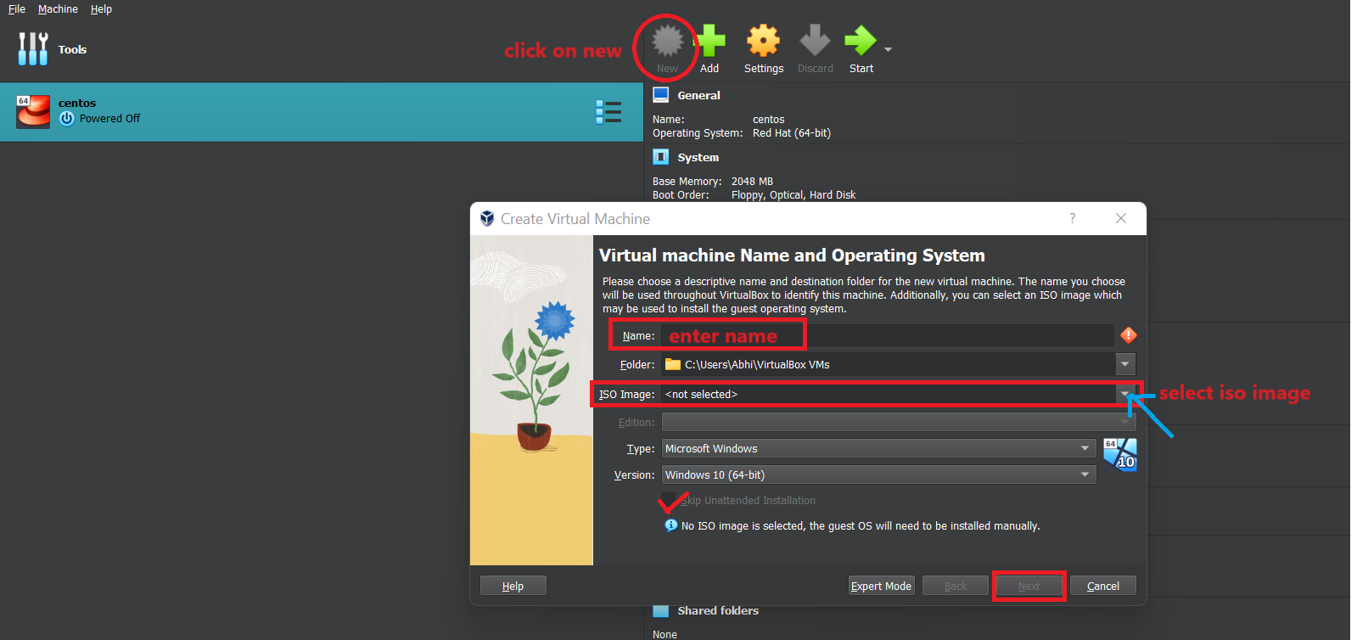

**Step 5 : Do this setting to avoid mouse problem**

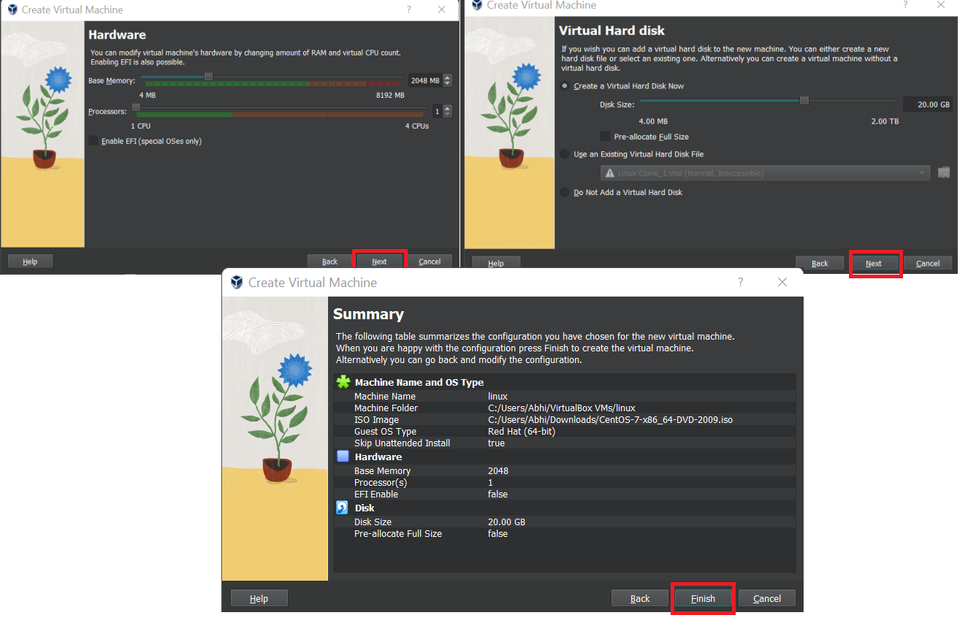

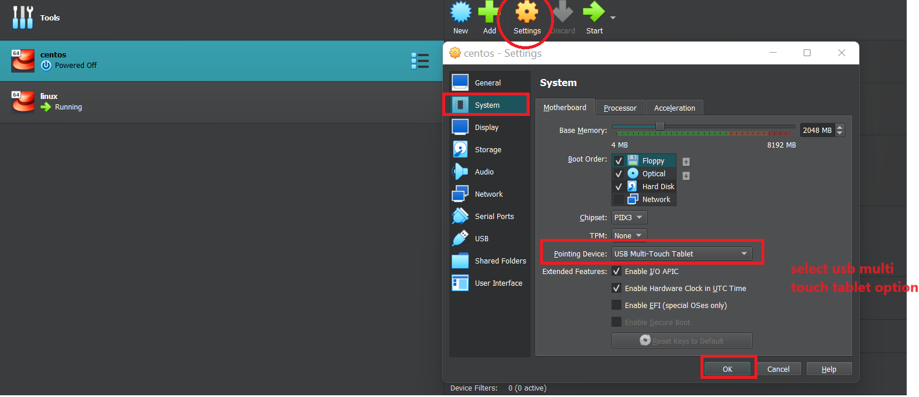

**Step 6**

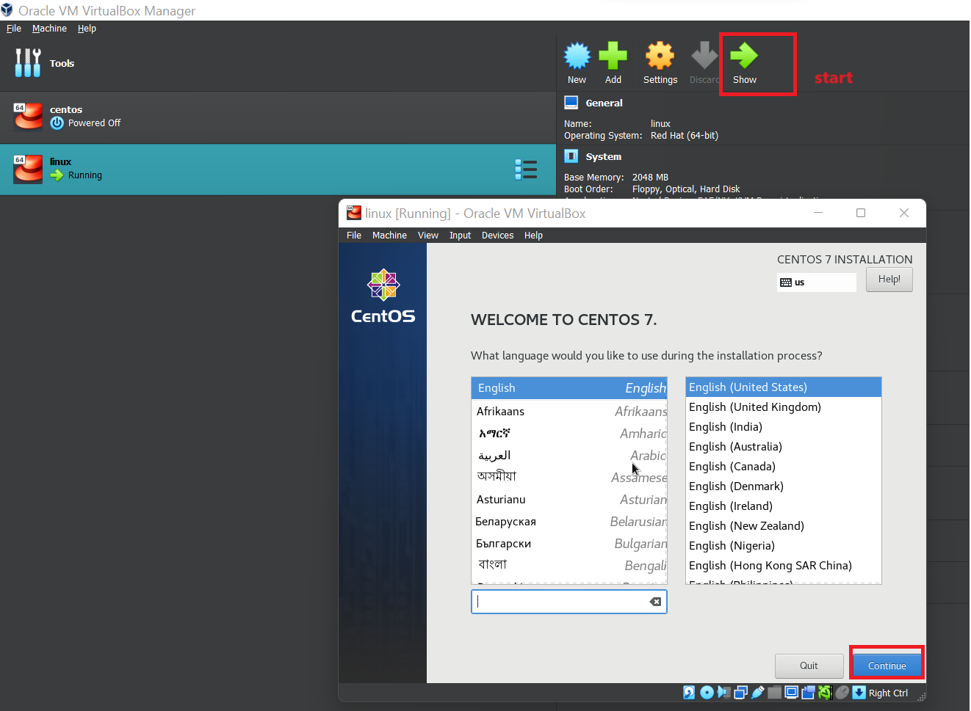

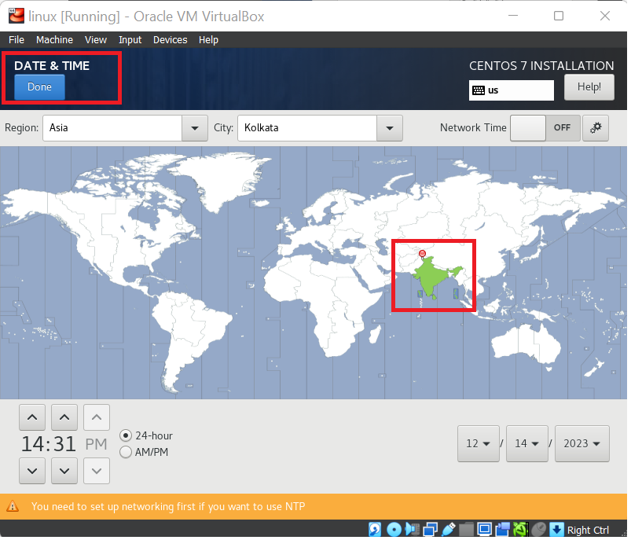

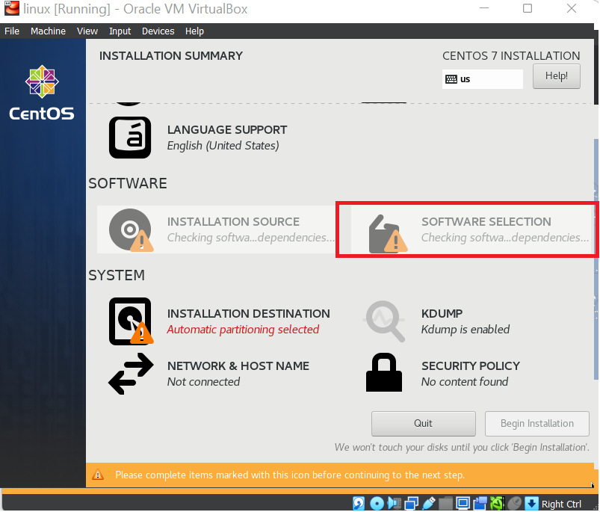

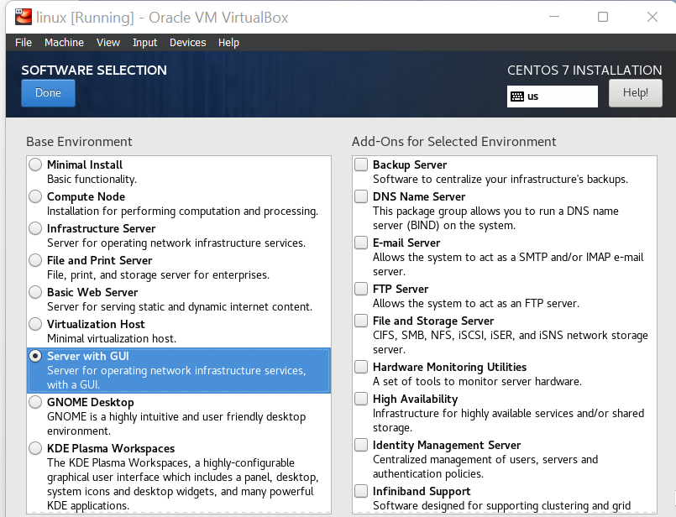

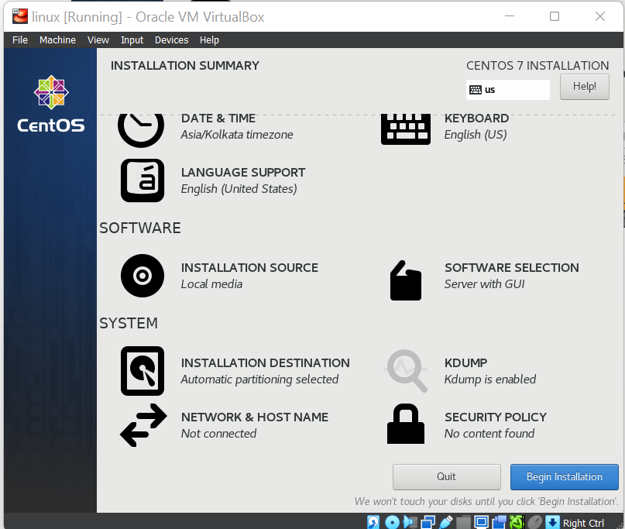

Step 7 -> Set Root Password